
National Textile University, Faisalabad
Department of Computer Science
Name: | AWAIS FAISAL
Class: | BSCS-5th (A)
Registration No: | 24-NTU-CS-FL-1020
Task: | HOMEWORK 2
Course Name: | IOT
Submitted To: | Sir NASIR
Submission Date: | 30-10-2026

Homework 2: Dual-LED PWM Fading with OLED Monitoring on ESP32

Objective
This homework uses the ESP32 hardware PWM (LEDC) to fade two LEDs at two different PWM frequencies. In Task 1 the two LEDs fade on their own. In Task 2 an SSD1306 OLED is added to show the live duty cycle and frequency of each LED. Both tasks were first built and tested in Wokwi, then wired on a real ESP32, and the files were pushed to GitHub after each task.

Task 1: Two LEDs at Different PWM Frequencies

Components
- ESP32 DevKit (ESP32 DevKit C in Wokwi)
- 1 red LED (LED 1) and 1 blue LED (LED 2)
- 2 resistors of 220 ohm, one in series with each LED

Wiring
Connection | Details
GPIO 18 | Through a 220 ohm resistor to the red LED anode; red LED cathode to GND
GPIO 19 | Through a 220 ohm resistor to the blue LED anode; blue LED cathode to GND

Every LED has its own resistor and its own GPIO pin, so the two LEDs can be controlled independently.

PWM frequency and resolution
 | LED 1 (red) | LED 2 (blue)
GPIO | 18 | 19
LEDC channel | 0 | 2
Frequency | 1000 Hz | 5000 Hz
Resolution | 8 bit (0 to 255) | 8 bit (0 to 255)

8 bits gives 256 brightness steps, which is smooth enough for a fade and can be generated at both 1 kHz and 5 kHz by the ESP32 timers. It also keeps the percentage easy to compute: duty x 100 / 255.

Technical check: LEDC timers
The ESP32 LEDC channels do not each have their own timer. Several channels share one timer, and channels on the same timer must use the same frequency and resolution. In the Arduino-ESP32 2.x core the channels are grouped in pairs (0 and 1, 2 and 3, and so on). If the second LED had used channel 1, setting it to 5 kHz would have changed channel 0 as well, and both LEDs would have ended up at the same frequency. For that reason LED 1 uses channel 0 and LED 2 uses channel 2, which sit on different timers, so 1 kHz and 5 kHz run at once. This mapping is for the original ESP32; the S2, S3 and C3 chips have different channel counts, so it must be checked again for those. The 3.x versions of the core use ledcAttach() and assign timers automatically, but this code uses the older ledcSetup() and ledcAttachPin() calls (PlatformIO platform espressif32 6.9.0).

Duty cycle and frequency
The duty cycle is the share of each PWM period during which the pin is HIGH. A larger duty cycle means the LED conducts for longer, so its average current and brightness go up. At 0 % the LED is off and at 100 % it is fully on. Human vision is not linear, so changes look larger at low duty values than at high ones.
The frequency is the number of on/off cycles per second. At 1 kHz one period lasts 1 ms and at 5 kHz it lasts 0.2 ms. Both are well above what the eye perceives as flicker, so the two LEDs look the same. The difference only shows on an oscilloscope or through switching noise in a circuit. A higher PWM frequency also leaves fewer timer bits for resolution, but 8 bits works at both frequencies.

Code (src/main.cpp)
#include <Arduino.h>
// ---- Pins ----
const uint8_t PIN_RED = 18; // LED 1 (red)
const uint8_t PIN_BLUE = 19; // LED 2 (blue)
// ---- LEDC channels (0 and 2 are on different timers) ----
const uint8_t CH_RED = 0;
const uint8_t CH_BLUE = 2;
// ---- PWM settings ----
const uint32_t FREQ_RED = 1000; // 1 kHz
const uint32_t FREQ_BLUE = 5000; // 5 kHz
const uint8_t RES_BITS = 8;
const int DUTY_MAX = (1 << RES_BITS) - 1; // 255
const int STEP_MS = 10;
void setup() {
Serial.begin(115200);
double realRed = ledcSetup(CH_RED, FREQ_RED, RES_BITS);
double realBlue = ledcSetup(CH_BLUE, FREQ_BLUE, RES_BITS);
if (realRed == 0 || realBlue == 0) {
Serial.println("ERROR: LEDC setup failed");
while (true) { delay(1000); }
}
ledcAttachPin(PIN_RED, CH_RED);
ledcAttachPin(PIN_BLUE, CH_BLUE);
ledcWrite(CH_RED, 0);
ledcWrite(CH_BLUE, 0);
Serial.println("Dual LED PWM Fade Started");
Serial.print("LED 1 Frequency: ");
Serial.print(realRed);
Serial.println(" Hz");
Serial.print("LED 2 Frequency: ");
Serial.print(realBlue);
Serial.println(" Hz");
}
void loop() {
// fade up
for (int d = 0; d <= DUTY_MAX; d++) {
ledcWrite(CH_RED, d);
ledcWrite(CH_BLUE, d);
delay(STEP_MS);
}
// fade down
for (int d = DUTY_MAX; d >= 0; d--) {
ledcWrite(CH_RED, d);
ledcWrite(CH_BLUE, d);
delay(STEP_MS);
}
}
Screenshot 1: Task 1 code in VS Code
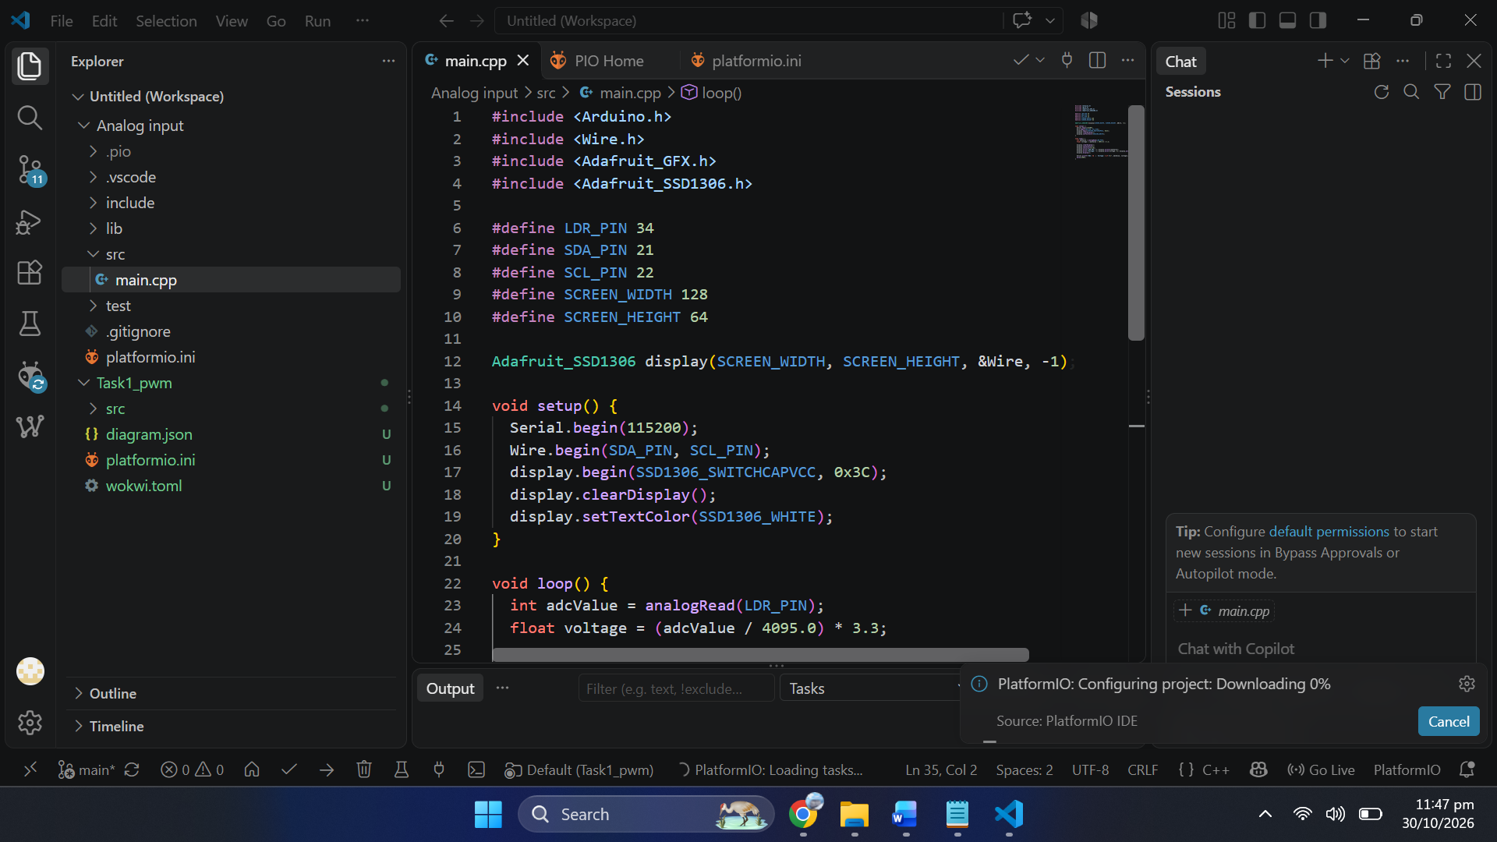

Screenshots
Screenshot 2: Wokwi circuit (Task 1)
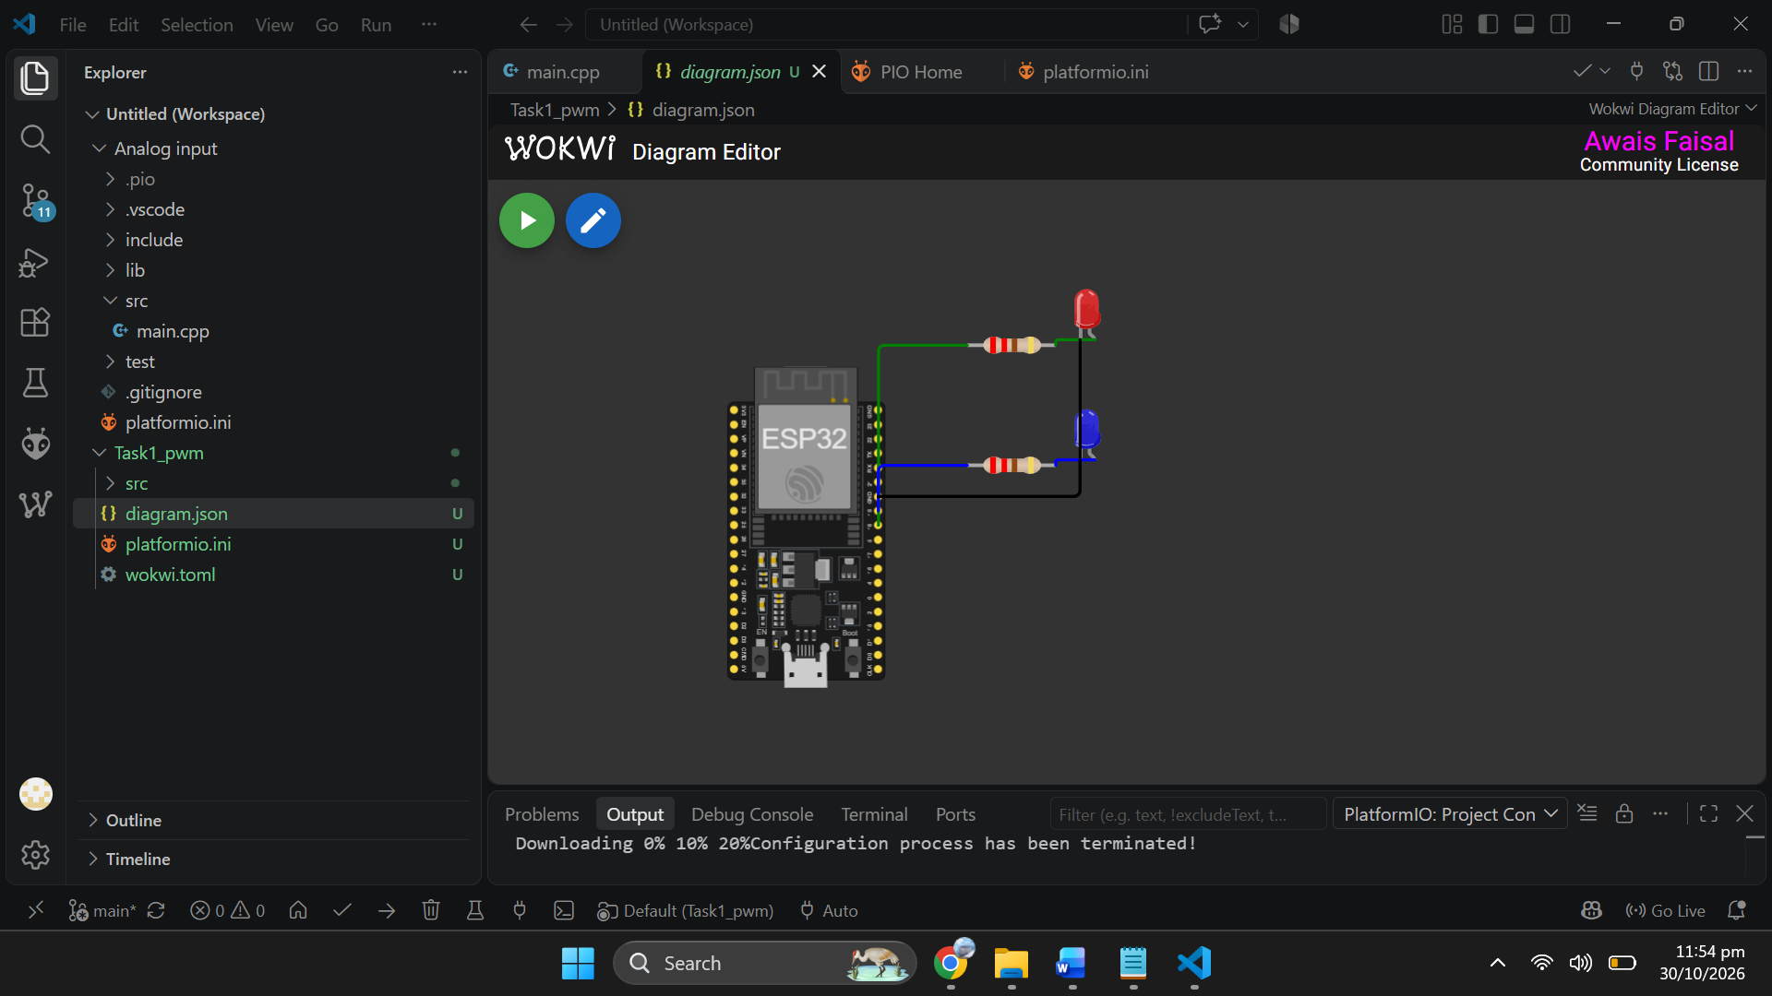
Caption: Wokwi diagram: ESP32 with the two LEDs and resistors on GPIO 18 and GPIO 19.
Screenshot 3: Wokwi simulation running (Task 1)
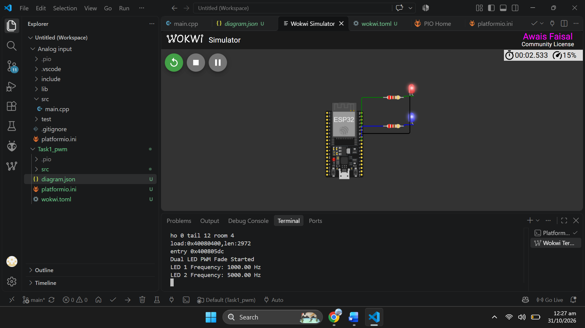
Caption: Running simulation with the serial monitor showing both frequencies.
Screenshot 4: Hardware circuit (Task 1)
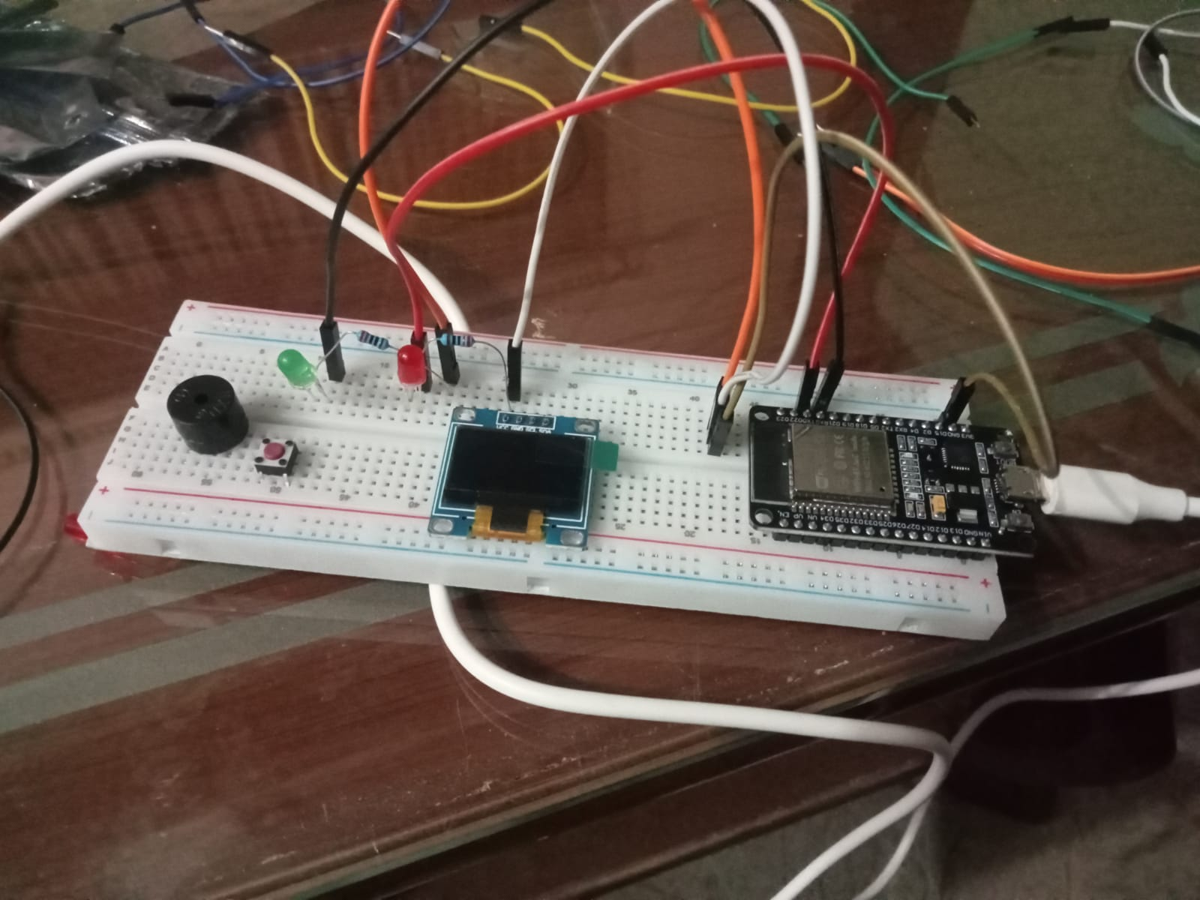
Caption: The real ESP32 circuit with the red and blue LEDs and resistors.
Screenshot 5: Hardware output (Task 1)
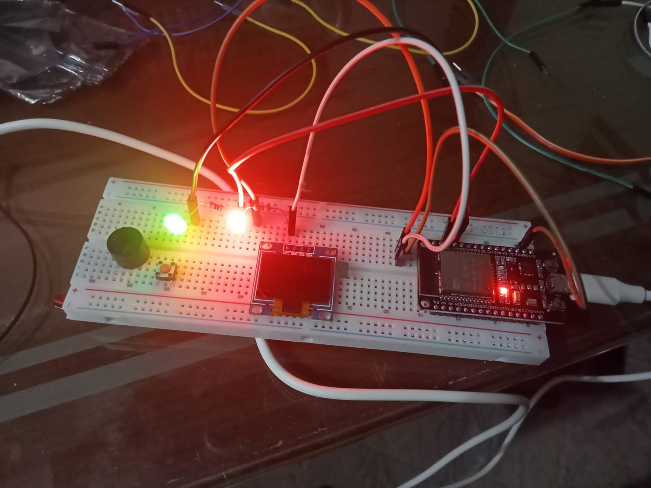
Caption: The LEDs fading on the real board.

Test results
At start-up the serial monitor (115200 baud) prints:
Dual LED PWM Fade Started
LED 1 Frequency: 1000.00 Hz
LED 2 Frequency: 5000.00 Hz
Both LEDs begin at 0, fade up to full brightness, fade back down and repeat. With a 10 ms step, the expected fade-up values are:
Time (approx.) | Duty value | Duty cycle | Brightness
0.00 s | 0 | 0 % | off
0.64 s | 64 | 25 % | dim
1.28 s | 128 | 50 % | medium
1.92 s | 192 | 75 % | bright
2.55 s | 255 | 100 % | full
Task 2: Showing the PWM Values on an OLED
Task 2 adds a 128x64 SSD1306 OLED (I2C, address 0x3C) to the same circuit. The screen shows the live duty cycle (%) and the PWM frequency of both LEDs.

OLED wiring
OLED pin | ESP32 pin
VCC | 3V3
GND | GND
SDA | GPIO 21
SCL | GPIO 22

The LED wiring from Task 1 stays the same.

How the program works
- showOLED() clears the display and draws three lines: a title, the LED 1 values and the LED 2 values, then calls display() to send the buffer to the screen.
- The percentage is calculated as duty x 100 / 255, from the same duty variables that are passed to ledcWrite().
- The frequencies come from the same constants that are passed to ledcSetup(), so the numbers on the screen always match what the ESP32 is using.
- setPwm() writes the duty to both channels, redraws the OLED and waits 10 ms. The fade loops call it for every step.
- If the OLED is not found, the program prints "OLED initialization failed!" on the serial monitor and stops.

Code (src/main.cpp)
#include <Arduino.h>
#include <Wire.h>
#include <Adafruit_GFX.h>
#include <Adafruit_SSD1306.h>
// ---- OLED ----
#define OLED_W 128
#define OLED_H 64
#define OLED_RESET -1
#define OLED_ADDR 0x3C
Adafruit_SSD1306 oled(OLED_W, OLED_H, &Wire, OLED_RESET);
// ---- Pins ----
const uint8_t PIN_RED = 18;
const uint8_t PIN_BLUE = 19;
// ---- LEDC channels (different timers) ----
const uint8_t CH_RED = 0;
const uint8_t CH_BLUE = 2;
// ---- PWM settings ----
const uint32_t FREQ_RED = 1000;
const uint32_t FREQ_BLUE = 5000;
const uint8_t RES_BITS = 8;
const int DUTY_MAX = (1 << RES_BITS) - 1;
const int STEP_MS = 10;
int dutyRed = 0;
int dutyBlue = 0;
void showOLED() {
int pctRed = dutyRed * 100 / DUTY_MAX;
int pctBlue = dutyBlue * 100 / DUTY_MAX;
oled.clearDisplay();
oled.setTextColor(SSD1306_WHITE);
oled.setTextSize(1);
oled.setCursor(0, 0);
oled.println("PWM MONITOR");
oled.setCursor(0, 18);
oled.print("LED1: ");
oled.print(pctRed);
oled.print("% F:");
oled.print(FREQ_RED);
oled.println("Hz");
oled.setCursor(0, 38);
oled.print("LED2: ");
oled.print(pctBlue);
oled.print("% F:");
oled.print(FREQ_BLUE);
oled.println("Hz");
oled.display();
}
void setPwm(int d) {
dutyRed = d;
dutyBlue = d;
ledcWrite(CH_RED, dutyRed);
ledcWrite(CH_BLUE, dutyBlue);
showOLED();
delay(STEP_MS);
}
void setup() {
Serial.begin(115200);
Wire.begin(21, 22);
if (!oled.begin(SSD1306_SWITCHCAPVCC, OLED_ADDR)) {
Serial.println("OLED initialization failed!");
while (true) { delay(1000); }
}
double realRed = ledcSetup(CH_RED, FREQ_RED, RES_BITS);
double realBlue = ledcSetup(CH_BLUE, FREQ_BLUE, RES_BITS);
if (realRed == 0 || realBlue == 0) {
Serial.println("ERROR: LEDC setup failed");
while (true) { delay(1000); }
}
ledcAttachPin(PIN_RED, CH_RED);
ledcAttachPin(PIN_BLUE, CH_BLUE);
Serial.println("Dual LED PWM + OLED Started");
Serial.print("LED 1 Frequency: ");
Serial.print(realRed);
Serial.println(" Hz");
Serial.print("LED 2 Frequency: ");
Serial.print(realBlue);
Serial.println(" Hz");
setPwm(0);
}
void loop() {
for (int d = 0; d <= DUTY_MAX; d++) { setPwm(d); }
for (int d = DUTY_MAX; d >= 0; d--) { setPwm(d); }
}
Screenshot 6: Task 2 code in VS Code
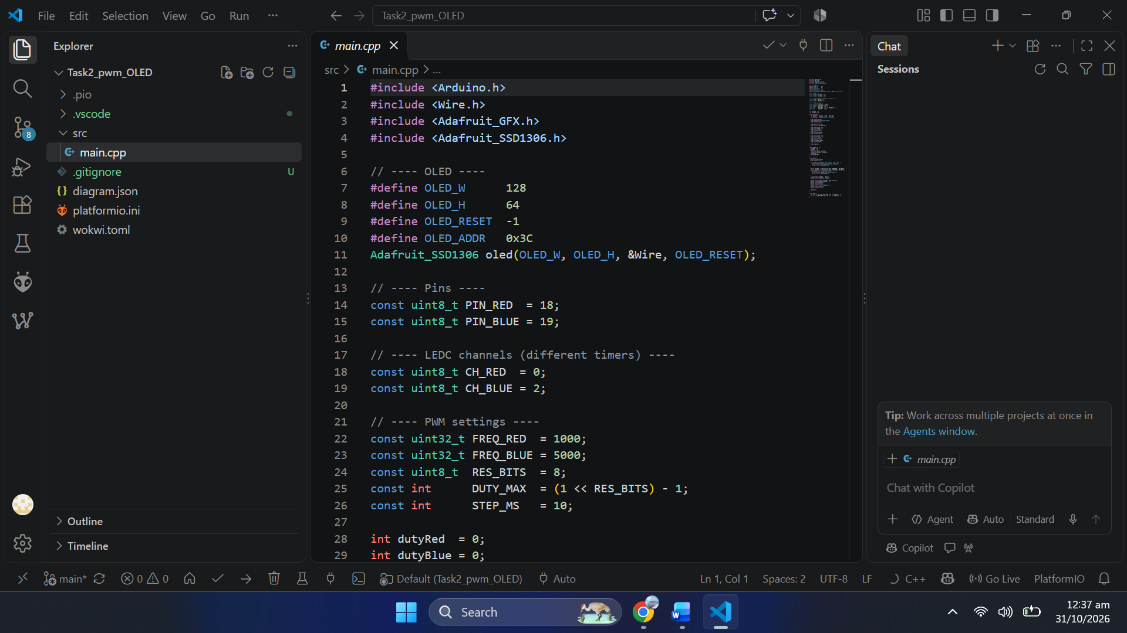
Caption: VS Code with the Task 2 project and main.cpp.

Screenshots
Screenshot 7: Wokwi circuit with OLED (Task 2)
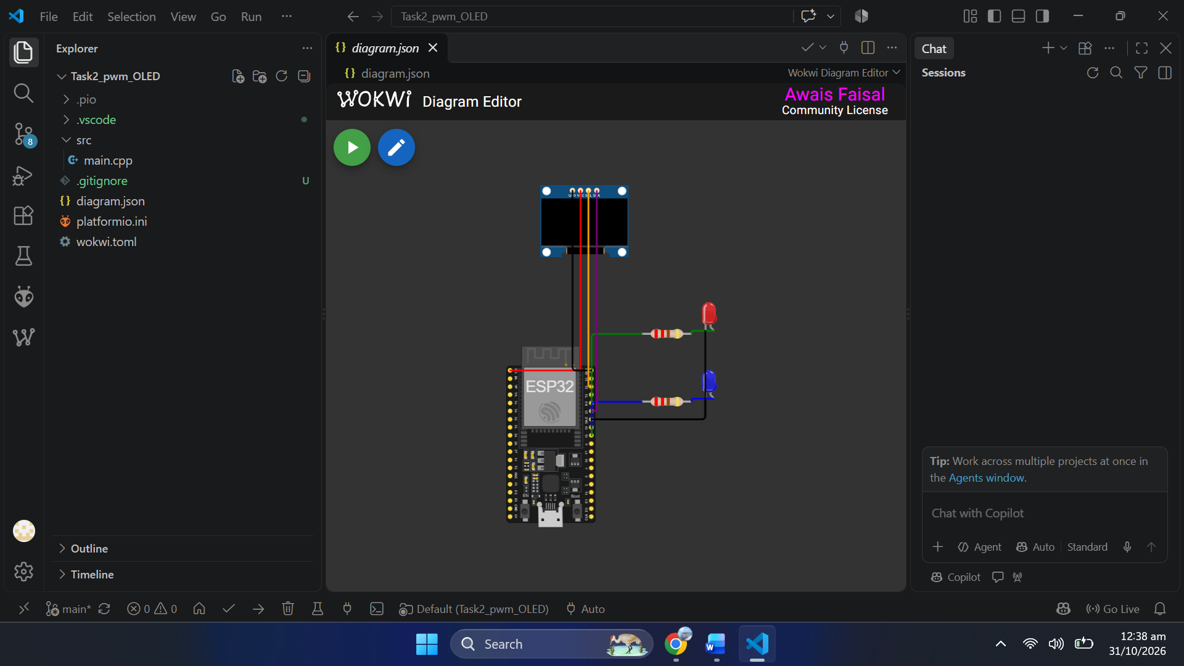
Caption: Wokwi diagram with the two LEDs and the SSD1306 OLED on GPIO 21 and GPIO 22.
Screenshot 8: Wokwi simulation with OLED running (Task 2)
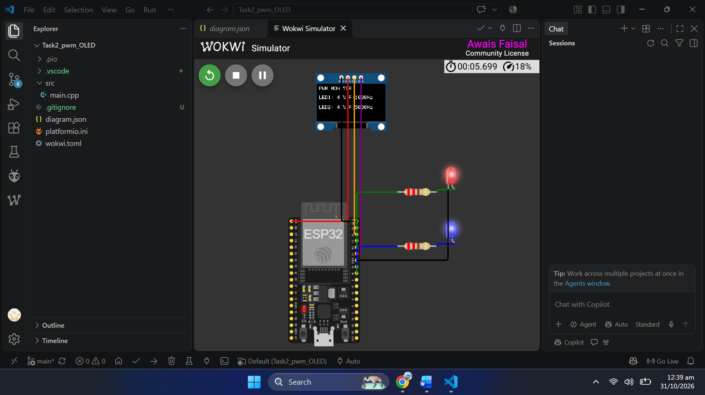
Caption: Running simulation: the OLED shows the duty cycle and frequency of each LED.
Screenshot 9: Hardware circuit (Task 2)
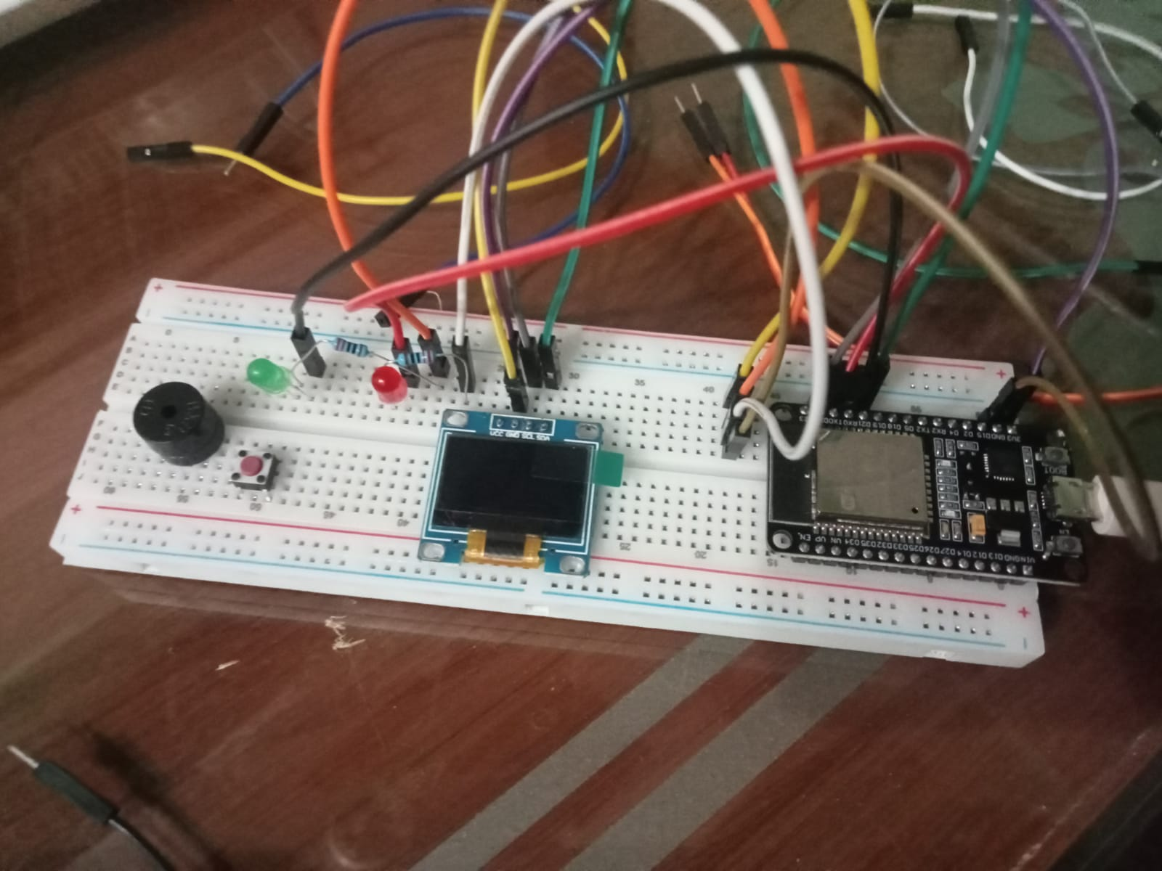
Caption: The real ESP32 circuit with the LEDs and the OLED.
Screenshot 10: Hardware OLED output (Task 2)
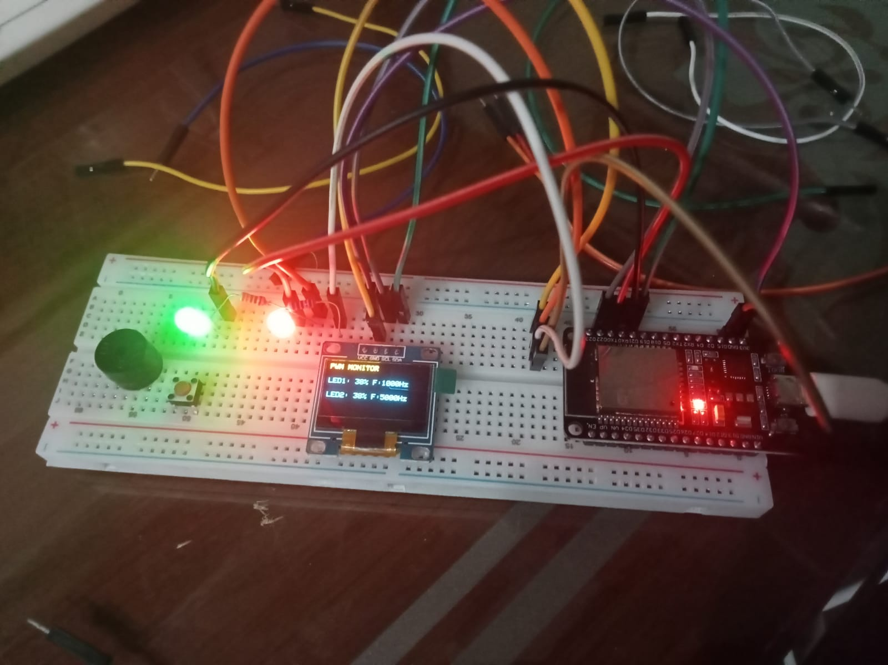
Caption: The real OLED showing the PWM monitor screen while the LEDs fade.

OLED output
The screen layout is shown below (here at a duty of 50 %). The percentages sweep from 0 % to 100 % and back, and the frequencies stay at 1000 Hz and 5000 Hz.
PWM MONITOR
LED1: 50% F:1000Hz
LED2: 50% F:5000Hz
Duty value | LED 1 line | LED 2 line | Brightness
0 | LED1: 0% F:1000Hz | LED2: 0% F:5000Hz | off
64 | LED1: 25% F:1000Hz | LED2: 25% F:5000Hz | dim
128 | LED1: 50% F:1000Hz | LED2: 50% F:5000Hz | medium
192 | LED1: 75% F:1000Hz | LED2: 75% F:5000Hz | bright
255 | LED1: 100% F:1000Hz | LED2: 100% F:5000Hz | full

Fade speed with the OLED
The code waits 10 ms per step and a full cycle has 512 steps (256 up and 256 down), which would be 5.12 s. Redrawing the OLED over I2C on every step adds time, so the real cycle is longer than that.

